Grammar: *The*, *a* / *an*

1. Complete the sentences. Use *the*, *a* or *an*.
   1. 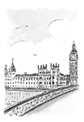  
      __________ Houses of Parliament are in London.
   2. 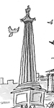  
      Nelson’s Column is __________ famous landmark in Trafalgar Square.
   3. 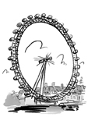  
      Look! The London Eye is on __________ other side of the River Thames.
   4.   
      **A** Excuse me. Is there _________ art gallery near here?  
      **B** Yes, it’s over there, on the other side of Trafalgar Square.
   5. 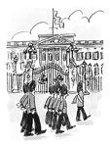  
      Look at the flag. That means the Queen is inside __________ palace.
   6. 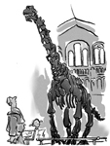  
      Let’s look at __________ dinosaurs in the Natural History Museum.
   7. 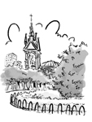  
      **A** Excuse me. Is there __________ park near here?   
      **B** Yes, Hyde Park is over there.
   8. 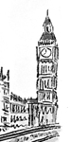  
      **A** Excuse me. How do I get to Big Ben?  
      **B** Walk along here until you see __________ bridge. Go across the bridge and Big Ben is on the other side.
2. Complete the sentences with *the, a* or *an*.
   1. Excuse me. How do I get to ________ bus station?
   2. Is there ________ bank near here?
   3. The museum is on ________ right, next to the shops.
   4. The restaurant is next to ________ old museum.
   5. Cross the road and you’ll come to ________ bridge.
   6. The theatre is next to ________ river.
   7. There isn’t ________ art gallery, but there is a museum.
   8. Excuse me. Where’s ________ *Savoy Hotel*?
3. Complete the questions and answers.
   1. **A** Excuse me. How do I get to the bus station?  
      **B** Go across ________ road and it’s opposite the bank.
   2. **A** Excuse me. Is there ________ bank near here? **B** Yes, it’s just there on the right.
   3. **A** Excuse me. Where’s the sports shop?  
      **B** It’s on ________ corner.
   4. **A** Excuse me. Is there ________ art gallery near here?  
      **B** Yes, it’s next to the museum.
   5. **A** Excuse me. How do I get to the museum?  
      **B** Go across the bridge and it’s on ________ left.
   6. **A** Excuse me. Where’s the Italian restaurant?  
      **B** Go past ________ bus stop and it’s on the right.
   7. **A** Excuse me. Where’s 52 Silver Street?  
      **B** Take the first left and you’ll come to ________ bridge. Go across the bridge and it’s the first on your right.
   8. **A** Excuse me. Is there ________ café near here?  
      **B** Yes, go across the road and it’s next to the book shop.