**REVISION UNIT 3**

LISTENING PRACTICE

1. Listen and answer the questions.

What was the speaker doing last night?

*He was watching TV.*

**1** What programme was on television?

___________________________________

**2** Where was the man walking?

___________________________________

**3** What were the children doing?

___________________________________

**4** What was the programme like at the beginning?

___________________________________

**5** Who found a body in the lake?

___________________________________

**6** Where did the girl find a body?

___________________________________

**7** What did the dog do?

___________________________________

PAST CONTINUOUS – practice

1. Choose the correct words.
   1. Mike **wasn’t / were** making a cheese sandwich.
   2. Nina and Oscar **were / was** watching a film.
   3. Betty **weren’t / was** washing her hair.
   4. We **wasn’t / weren’t** having breakfast in a café.
   5. The two girls **were / wasn’t** doing their homework.
   6. Joe **weren’t / was** switching on the radio.
   7. Rita **wasn’t / were** getting ready for the party.
   8. Hamish and Miles **was / weren’t** walking on the beach.

**PAST CONTINUOUS**

WAS / WERE + ‘verb‘-ing

We **were** play**ing** football.

She **was** play**ing** football.

1. Complete the sentences with the past continuous. Use the verbs in brackets.

Patricia *was sending* an e-mail. (send)

**1** We _____________ dinner at 8.00. (have)

**2** Bryan _____________ a shower. (not have)

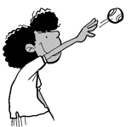

**3** Mercy _____________ a ball in the park. (throw)

**4** Tom _____________ a hat. (not wear)

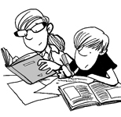

**5** The boys _____________ TV. (not watch)

**6** Mary and John _____________ on the sofa. (sit)

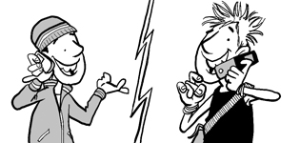

**7** Chris and Simon _____________ on the phone. (talk)

1. Correct the sentences.
2. Anna was play the guitar. __________________________________
3. Mick and Richard was taking photos. __________________________________
4. Dad was to feeding the dog. __________________________________
5. I were cleaning my shoes. __________________________________
6. They were geting ready for school. __________________________________
7. My friends were buiing clothes. __________________________________
8. Zac was to read a sports magazine. __________________________________